POS SYSTEM – Use-case

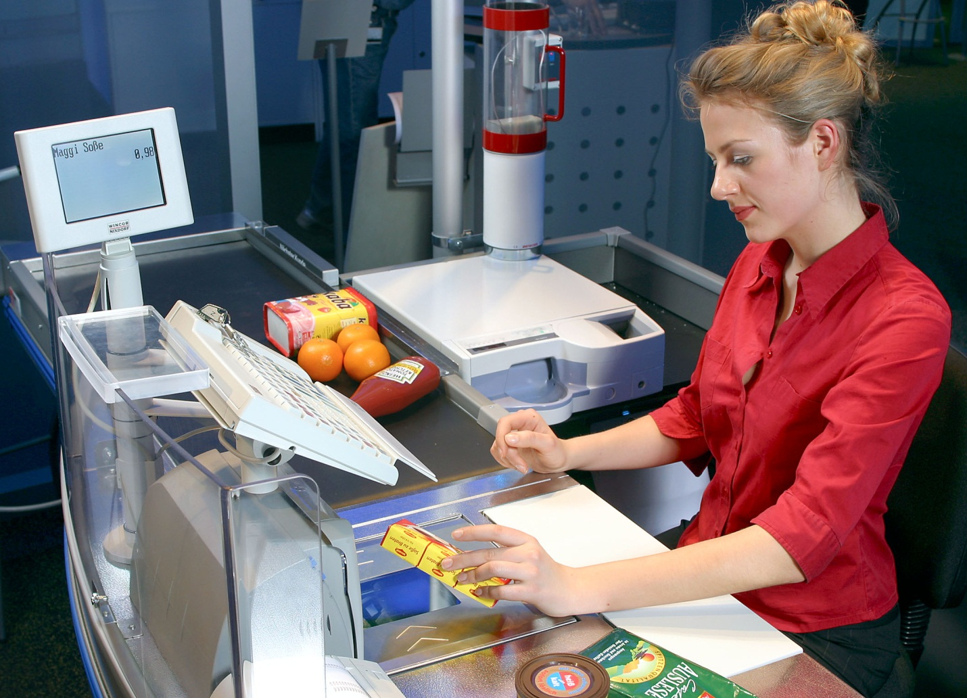

HIT Team

Consulting

Sales

Staffing

Support

Information of document

|  |  |
| --- | --- |
| **Title** | **Use-case Document** |
| **Author(s)** | All team |
| **Reviewer(s)** | All team |
| **Team name** | HIT Team |
| **Team members** | Thanh Giang, Hiep Ta, Phuc Nguyen, Giang Nguyen, Dat Tran, Huy Huynh |
| **Project mentors** | Ms. Huong Nguyen, Mr. Huyen Pham |
| **Editor** |  |
| **Type of report** | Use-case Document |
| **Software used** | MS Word |

Document Reviewer Information

|  |  |  |
| --- | --- | --- |
| Reviewer Name | Review Attendance (R/S) | Comments |
|  |  |  |
|  |  |  |
|  |  |  |

Document Approver Information

|  |  |  |
| --- | --- | --- |
| Approver Name | Approver Function | Comments |
|  |  |  |
|  |  |  |
|  |  |  |

Document Revision History

|  |  |  |  |
| --- | --- | --- | --- |
| Date | Revision | Change Summary | Revised by |
| 10/06/2012 | 0.3 | Update UC | Hiep Ta, Phuc Nguyen, Thanh Giang |
| 15/06/2012 | 0.4 | Update UC | Hiep Ta |
|  |  |  |  |
|  |  |  |  |
|  |  |  |  |

Table of content

1. Use case: Level 1 2

1.1. Level 2 - System Management 3

1.2. Level 2 - Member Management 4

1.3. Level 2 - Type Management 4

1.4. Level 2 - Product Management 5

1.5. Level 2 - Bill Management 5

1.6. Level 2 - Retail Stores Management 6

1.7. Level 2 – User Computer Management 6

2. Use case Descriptions 7

2.1. System Management 7

2.2. Member Management 10

2.3. Type Management 14

2.4. Product Management 15

2.5. Bill Management 17

2.6. Retail Stores Management 19

2.7. User Computer Management 21

# Use case: Level 1

***Note Table:***

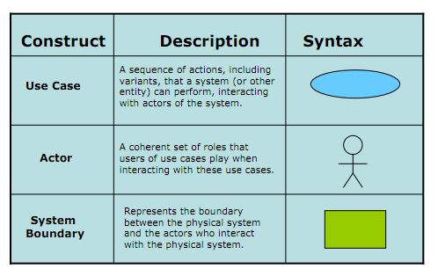

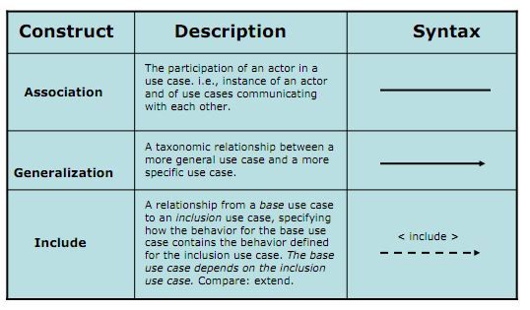



## Level 2 - System Management



## Level 2 - Member Management



## Level 2 - Type Management



## Level 2 - Product Management



## Level 2 - Bill Management



## Level 2 - Retail Stores Management



## Level 2 - POST Management



# Use case Descriptions

## Template



## System Management

|  |  |
| --- | --- |
| **Use Case Title: Add new user** | **Use Case ID: UC_SM01** |
| **General Use Case Description:** This function allows admin create new user. | |
| **Entities Involved: Admin** | |
| **Preconditions:**   1. Admin chooses System Management. 2. Admin chooses “add new user” function, add new user GUI ready for admin to interact. | |
| **Primary Use Case Flow of Events:**   1. Admin fill the required information about user. 2. Admin choose user authorization :  * Staff * Cashier * Manager  1. Admin click button Create 2. System show notification that Create a new user successfully 3. System show new created user in user list. 4. End of create new user | |
| **Primary Use Case Post Conditions:**  Successful: show notification that Create a new user successfully, show new created user in user list.  Fail: show notification that Create a new user unsuccessfully. | |
| **Alternate Use Case #1 Flow of Events:** | |
| **Alternate Use Case #1 Post Events:** | |

|  |  |
| --- | --- |
| **Use Case Title: Search/ View user list** | **Use Case ID:** UC_SM02 |
| **General Use Case Description:** This function allow admin Search and View user list | |
| **Entities Involved: Admin** | |
| **Preconditions:**   1. Admin chooses System Management. 2. User list GUI available and ready for admin to interact. | |
| **Primary Use Case Flow of Events:**   1. System show the user list of all user 2. Admin choose search condition:  * Username * User ID * Store name  1. Admin input key word to textbox: 2. System show the user list which satisfy the key word 3. End search/ view user list. | |
| **Primary Use Case Post Conditions:**  Search successful, user list which satisfy the key word show up in GUI. | |
| **Alternate Use Case #1 Flow of Events:** | |
| **Alternate Use Case #1 Post Events:** | |

|  |  |
| --- | --- |
| **Use Case Title: View user detail Information** | **Use Case ID:** UC_SM03 |
| **General Use Case Description:** This function allows admin View user detail information | |
| **Entities Involved: Admin** | |
| **Preconditions:**  Admin is viewing the user list | |
| **Primary Use Case Flow of Events:**   1. Admin double click to user need to view detail information. 2. System shows the user detail information. 3. End of View user detail Information | |
| **Primary Use Case Post Conditions:**  System shows the user detail information. | |
| **Alternate Use Case #1 Flow of Events:** | |
| **Alternate Use Case #1 Post Events:** | |

|  |  |
| --- | --- |
| **Use Case Title: Update User Information, Assign authorize** | **Use Case ID:** UC_SM04 |
| **General Use Case Description:** This function allows admin Update User Information and Assign authorize | |
| **Entities Involved: Admin** | |
| **Preconditions:**  Admin is viewing user detail information | |
| **Primary Use Case Flow of Events:**   1. Admin changes user authorize if needed. 2. Admin change or update user information. 3. Admin click Update | |
| **Primary Use Case Post Conditions:**  System show notification that update user information successful. | |
| **Alternate Use Case #1 Flow of Events:** | |
| **Alternate Use Case #1 Post Events:** | |

## Member Management

|  |  |
| --- | --- |
| **Use Case Title: Add new Member** | **Use Case ID:** UC_C01 |
| **General Use Case Description:** This function allows staff create new Member | |
| **Entities Involved:** Staff | |
| **Preconditions:**   1. Staff choose member management 2. Staff Add new member function, Add new member GUI ready for staff to interact | |
| **Primary Use Case Flow of Events:**   1. Staff fill required information of member:  * Name (required) * Birthday (required) * Address (optional) * ID number (required) * Gender (required)  1. Staff click button Create 2. System shows the notification that Add new member successfully 3. System show new created member in user list. 4. End of create new member | |
| **Primary Use Case Post Conditions:**  Successful: Add new member successfully. System show new created member in user list.  Fail: show notification that Create a new member unsuccessfully. | |
| **Alternate Use Case #1 Flow of Events:**   1. If required information was blank 2. System shows the notification that some information needs to be filled to create new member. 3. Staff fill required information 4. Staff click create again. 5. Continue step 3 of primary flow   **Alternate Use Case #2 Flow of Events:**   1. If ID number was duplicated. 2. System shows the notification that ID number was duplicated 3. Staff check the ID number 4. Staff click create again. 5. Continue step 3 of primary flow | |
| **Alternate Use Case #1 Post Events:** | |

|  |  |
| --- | --- |
| **Use Case Title: Search/ View member list** | **Use Case ID:** UC_C02 |
| **General Use Case Description:** This function allows staff Search/ View member list | |
| **Entities Involved: Staff** | |
| **Preconditions:**   1. Staff chooses member Management. 2. Member list GUI available and ready for admin to interact. | |
| **Primary Use Case Flow of Events:**   1. System show the member list 2. Staff choose search condition:  * member name * member ID number * Store name  1. Staff input key word to textbox: 2. System show the user list which satisfy the key word 3. End search/ view member list. | |
| **Primary Use Case Post Conditions:**  Search successful, member list which satisfy the key word show up in GUI. | |
| **Alternate Use Case #1 Flow of Events:**  **View member detail information:**  After searching the member list that users can view member detail information by following these steps :   1. DoubleClick on the member 2. The system appears interface member information. 3. User can view and interact on the interface.   **Update Member information:**  After view member detail information that users can update member information by following these steps :   1. User can edit information on the interface include:  * Name * Birthday * Address * Gender  1. User select “save" to save the information to the data. 2. Notification system to update successfully.   **View member point Log:**  After view member detail information that users can view member point Log by following these steps :   1. Select view point log in interface of member information. 2. Select “OK” to exit the interface point log | |
| **Alternate Use Case #1 Post Events:** | |

## Type Management

|  |  |
| --- | --- |
| **Use Case Title: Add new Type** | **Use Case ID:** UC_CM01 |
| **General Use Case Description:** This function allows Staff create new Type. | |
| **Entities Involved: Staff** | |
| **Preconditions:**   1. Staff chooses Type management 2. Create new Type GUI available and ready for staff to interact. | |
| **Primary Use Case Flow of Events:**   1. Staff input Type name 2. The notes to the Type. 3. ID number (system default allocation order) 4. Staff click Create button 5. System show the notification that create new Type successfully 6. End of create new Type | |
| **Primary Use Case Post Conditions:**  Successful: create new Type successfully, new Type appear in Type list  Fail: System show the notification that create new Type unsuccessfully | |
| **Alternate Use Case #1 Flow of Events:**   1. Type name was duplicated 2. System show the notification that Type name was duplicated 3. Staff input another Type name 4. Staff click Create 5. Continue step 3 in primary flow | |
| **Alternate Use Case #1 Post Events:** | |

|  |  |
| --- | --- |
| **Use Case Title: Search/ View Type list** | **Use Case ID:** UC_CM02 |
| **General Use Case Description:** This function allows staff Search/ View Type list | |
| **Entities Involved: Staff** | |
| **Preconditions:**   1. Staff chooses Type Management. 2. Type list GUI available and ready for admin to interact. | |
| **Primary Use Case Flow of Events:**   1. System show the Type list 2. Staff choose search condition:  * Type name * creation date * ID number  1. Staff input key word to textbox: 2. System show the user list which satisfy the key word 3. End search/ view Type list. | |
| **Primary Use Case Post Conditions:**  Search successful, Type list which satisfy the key word show up in GUI. | |
| **Alternate Use Case #1 Flow of Events:**  **View Type detail information:**  After searching the Type list that users can view Type detail information by following these steps :   1. DoubleClick on the Type 2. The system appears interface Type information. 3. User can view and interact on the interface.   **Update Type information:**  After view Type detail information that users can update Type information by following these steps :   1. User can edit information on the interface include:  * Name * Notes  1. User select “save" to save the information to the data. 2. Notification system to update successfully.   **Enable/Disable Type:**  After view Type detail information that users can update Type information by following these steps :   1. User can enable/disable by tick the box 2. Users click "save" 3. Notification system “are you sure” 4. User clicks "OK" to save the information to the data. | |
| **Alternate Use Case #1 Post Events:** | |

## Product Management

|  |  |
| --- | --- |
| **Use Case Title: Add new product** | **Use Case ID:** UC_PM01 |
| **General Use Case Description:** This function allows Staff create new product. | |
| **Entities Involved: Staff** | |
| **Preconditions:**   1. Staff chooses product management 2. Create new product GUI available and ready for staff to interact. | |
| **Primary Use Case Flow of Events:**   1. Staff input product name 2. ID number (system default allocation order) 3. Staff chooses Type 4. Staff input product price 5. Staff click Create button 6. System show the notification that create new product successfully 7. End of create new product | |
| **Primary Use Case Post Conditions:**  Successful: create new product successfully, new product appear in product list.  Fail: System show the notification that create new product unsuccessfully | |
| **Alternate Use Case #1 Flow of Events:**   1. Product name was duplicated 2. System show the notification that Product name was duplicated 3. Staff input another product name 4. Staff click Create 5. Continue step 5 in primary flow | |
| **Alternate Use Case #1 Post Events:** | |

|  |  |
| --- | --- |
| **Use Case Title: Search/ View product list** | **Use Case ID:** UC_PM02 |
| **General Use Case Description:** This function allows staff Search/ View product list | |
| **Entities Involved: Staff** | |
| **Preconditions:**   1. Staff chooses product Management. 2. Product list GUI available and ready for admin to interact. | |
| **Primary Use Case Flow of Events:**   1. System show the product list 2. Staff choose search condition:  * product name * creation date * ID number  1. Staff input key word to textbox: 2. System show the user list which satisfy the key word 3. End search/ view product list. | |
| **Primary Use Case Post Conditions:**  Search successful, product list which satisfy the key word show up in GUI. | |
| **Alternate Use Case #1 Flow of Events:**  **View product detail information:**  After searching the product list that users can view product detail information by following these steps :   1. DoubleClick on the product 2. The system appears interface product information. 3. User can view and interact on the interface.   **Update product information:**  After view product detail information that users can update product information by following these steps :   1. User can edit information on the interface include:  * Name * Price * Notes  1. User select “save" to save the information to the data. 2. Notification system to update successfully.   **Enable/Disable product:**  After view product detail information that users can update product information by following these steps :   1. User can enable/disable by tick the box 2. Users click “save" 3. Notification system “are you sure” 4. User clicks "OK" to save the information to the data. | |
| **Alternate Use Case #1 Post Events:** | |

## Bill Management

|  |  |
| --- | --- |
| **Use Case Title: Add New Bill** | **Use Case ID:** UC_RM01 |
| **General Use Case Description:** This use case helps cashiers who work at retail stores make bill-paying for member. Cashier can use barcode reader or directly enter the product code and product number by keyboard, then use the payment function to save to database and printed out bills for member. | |
| **Entities Involved: Cashier** | |
| **Preconditions:**   1. User is assigned authorized to use this function 2. User has chosen Bill Management function 3. The system is available. | |
| **Primary Use Case Flow of Events:**   1. User choose “Add new bill” button 2. Program displays Add new store GUI 3. User fills in Bar Code text field 4. User choose “Add” button 5. The system load information from database to the “Product List” table on the interface. 6. User fills in Quantity text field 7. User scan or fill in member Loyalty card ID 8. The system load information from database and show member name with their point on the interface 9. If member want to use their point to pay bill, User choose “Type to pay bill” 10. There are three ways to pay bill: 11. Pay by cash: User does not fill in “Point” text field. The system auto shows all the money member has to pay in “Cash” text field. 12. Pay by point: User fills in “Point” text field if user has enough point to pay that bill, the system auto shows “0 VND” in “Cash” text field. 13. Pay by point and cash: User fills in “Point” text field; the system shows money that member still has to pay with that bill in “Cash” text field. 14. User choose “Pay by Cash” 15. User choose Pay bill button 16. ID number (system default allocation order) 17. The system stores the bill’s information that has just been created and prints the bill. Then the program returns to bill management interface 18. End Use-case | |
| **Primary Use Case Post Conditions:**  Successful: Create new successful. The system stores the bill’s information that has just been created and prints the bill. Then the program returns to bill management interface  Fail: Can’t print the bill | |
| **Alternate Use Case #1 Flow of Events:**   1. The bar code is invalid (starting from step 5 of the main flow) 2. Program loads information from database and shows message “The bar code is invalid” 3. User clicks "OK" to confirm 4. Program allows user to retype the bar code 5. End Use-case | |
| **Alternate Use Case #1 Post Events:** | |

|  |  |
| --- | --- |
| **Use Case Title: Search/ View bill list** | **Use Case ID:** UC_RM02 |
| **General Use Case Description:** This function allows staff Search/ View bill list | |
| **Entities Involved: Cashier** | |
| **Preconditions:**   1. Cashier chooses Bill Management. 2. Product list GUI ready for admin to interact. | |
| **Primary Use Case Flow of Events:**   1. System show the bill list 2. Staff choose search condition:  * creation date * ID number  1. Cashier type key word to search box: 2. System show the user list which satisfy the key word 3. End search/ view bill list. | |
| **Primary Use Case Post Conditions:**  Search successful, bill list which satisfies the key word show up in GUI. | |
| **Alternate Use Case #1 Flow of Events:**  **View bill detail information:**  After searching the bill list that users can view bill detail information by following these steps :   1. DoubleClick on the bill 2. The system appears interface bill information. 3. User can view and interact on the interface. | |
| **Alternate Use Case #1 Post Events:** | |

## Retail Stores Management

|  |  |
| --- | --- |
| **Use Case Title:** Add New Store | **Use Case ID:** UC_RSM01 |
| **General Use Case Description:** This use case help the manager add new sale store. | |
| **Entities Involved:** Manager | |
| **Preconditions:**   1. User is assigned authorized to use this function 2. User has chosen Retail Stores Management function 3. The system is available | |
| **Primary Use Case Flow of Events:**   1. User choose “Add new store” button 2. Program displays “Add new store” GUI for user to interact 3. User input information  * Store Name * Store Address  1. User to select POST and then click add post (you can add multiple post in store) 2. User select the Type add to the store. 3. Users select the Type products and pricing for that product, shelf price. 4. User clicks "OK". 5. The system returned to retail store management interface and show new created store in Retail Store list 6. End Use-case | |
| **Primary Use Case Post Conditions:**  Successful: Create new successful. The system stores the retail store’s information that has just been created and returned to retail store management interface  Fail: Failed to create new | |
| **Alternate Use Case #1 Flow of Events: Duplicated Store name**  [Starting from step 8 of the main flow]   1. User clicks "OK" 2. Program check in database and found that Store name was duplicated 3. Program display warning dialog “Store name was duplicated. Please fill in again” 4. User change the store name 5. Continue step 8 of main flow   **Alternate Use Case #2 Flow of Events: Change product price**  [Start from step 7 of main flow]   1. User click to product price 2. System allow user change the product price 3. User change the product price 4. User click outside the product price area 5. System show the new product price 6. Continue step 8 of main flow | |
| **Alternate Use Case #1 Post Events:** | |

|  |  |
| --- | --- |
| **Use Case Title: Search/ View store list** | **Use Case ID:** UC_RSM02 |
| **General Use Case Description:** This function allows staff Search/ View store list | |
| **Entities Involved:** Manager | |
| **Preconditions:**   1. Staff chooses store Management. 2. Store list GUI available and ready for admin to interact. | |
| **Primary Use Case Flow of Events:**   1. System show the store list 2. Manager choose search condition:  * store name * creation date * ID number  1. Manager input key word to textbox: 2. System show the user list which satisfy the key word 3. End search/ view store list. | |
| **Primary Use Case Post Conditions:**  Search successful, store list which satisfy the key word show up in GUI. | |
| **Alternate Use Case #1 Flow of Events:**  **View store detail information:**  After searching the store list that users can view store detail information by following these steps   1. DoubleClick on the store 2. The system appears interface store information. 3. User can view and interact on the interface.   **Update store information:**  After view store detail information that users can update store information by following these steps :   1. User can edit information on the interface include:  * Name * Address * Other information (POST, Type, Product ....)  1. User select “save" to save the information to the data. 2. Notification system to update successfully. | |
| **Alternate Use Case #1 Post Events:** | |

## POST Management

|  |  |
| --- | --- |
| **Use Case Title: Add new POST** | **Use Case ID:** UC_P01 |
| **General Use Case Description:** This feature allows admins to add new one MAC address of the computer that allows the computer to use the functionality of the system. This function is only limited access from the cashier's account. | |
| **Entities Involved: Admin** | |
| **Preconditions:**  Admin user select a computer to add new  User interface to add new computer appears ready for user interaction. | |
| **Primary Use Case Flow of Events:**   1. Users enter the MAC address of the computer to add MAC ID box. 2. Select a store located computer. 3. Select Add new. 4. Notification appears that “Add new Successful” 5. Select "OK" return to the User computer management. | |
| **Primary Use Case Post Conditions:**  Successful: User computer to appear in the list of User Computer.  Fail: cannot add new | |
| **Alternate Use Case #1 Flow of Events:**  MAC address have already been on the system : (start from step 2 of the main step)   1. The message system MAC address was available. 2. Select "OK" to enter the MAC address. 3. Select Add new. 4. Notification appears that “Add new Successful” 5. Select "OK" return to the User computer management.   MAC address have already been on the system : (start from step 1 of the main step)   1. The message system MAC address was available. 2. Select "OK" to enter the MAC address. 3. Select Add new. 4. Notification appears that “Add new Successful” 5. Select "OK" return to the User computer management. | |
| **Alternate Use Case #1 Post Events:** | |

|  |  |
| --- | --- |
| **Use Case Title:** Search/ View POST list | UC_P02 |
| **General Use Case Description:** This function allows staff Search/ View POST list | |
| **Entities Involved:** Admin | |
| **Preconditions:**   1. Staff chooses POST Management. 2. Store list GUI available and ready for admin to interact. | |
| **Primary Use Case Flow of Events:**   1. System show the POST list 2. Admin choose search condition:  * creation date * MAC ID * Store  1. Admin input key word to textbox: 2. System show the user list which satisfy the key word 3. End search/ view POST list. | |
| **Primary Use Case Post Conditions:**  Search successful, store list which satisfy the key word show up in GUI. | |
| **Alternate Use Case #1 Flow of Events**:  View product detail information:  After searching the POST list that users can view POST detail information by following these steps :   1. DoubleClick on the POST 2. The system appears interface POST information. 3. User can view and interact on the interface.   Update product information:  After view UC detail information that users can update POST information by following these steps :   1. User can edit information on the interface include:  * Store  1. User select “save" to save the information to the data. 2. Notification system to update successfully. | |
| **Alternate Use Case #1 Post Events:** | |

**-- The End --**